

**Discipline**

**Configure a RDS with Postgres SQL and create 2 table in it.**

**CS5002**

Activity-13

**Sheikh Muhammed Tadeeb (AU19B1014)**

* **Problem Statement:**

Create a Ec2 instance and attached a EBS Volume of 50 GB Size.

Mount that Volume on Linux machine.

Provide the out of the Volume mounted on your Linux machine using df -h command.

* **Solution:**

**Step 1:** We created an instance named Ec2-volume-attach for attaching volume.

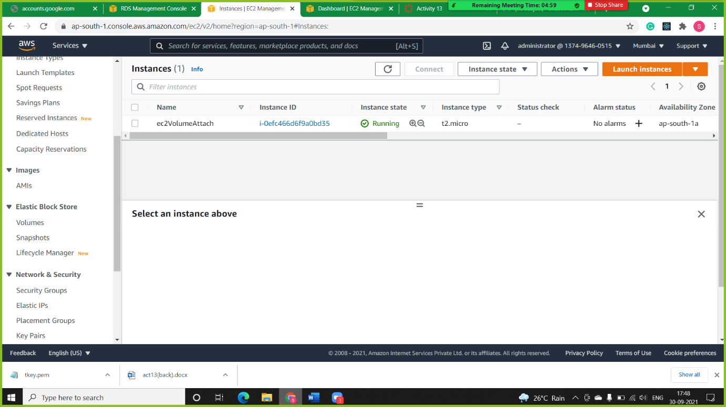

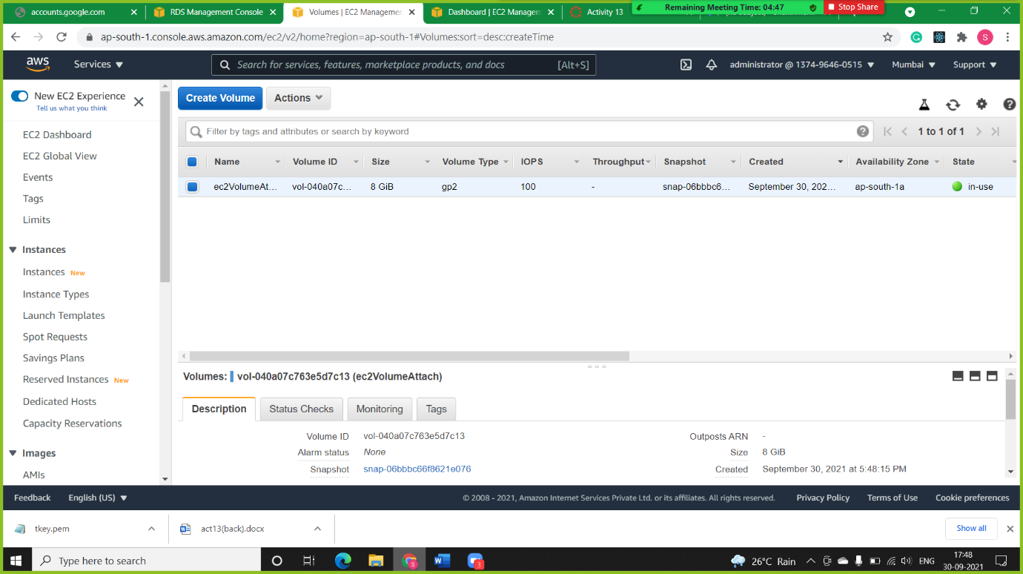**Step 2:** We are creating volume with general purpose SSD (gp3) type and size of 50 GB.

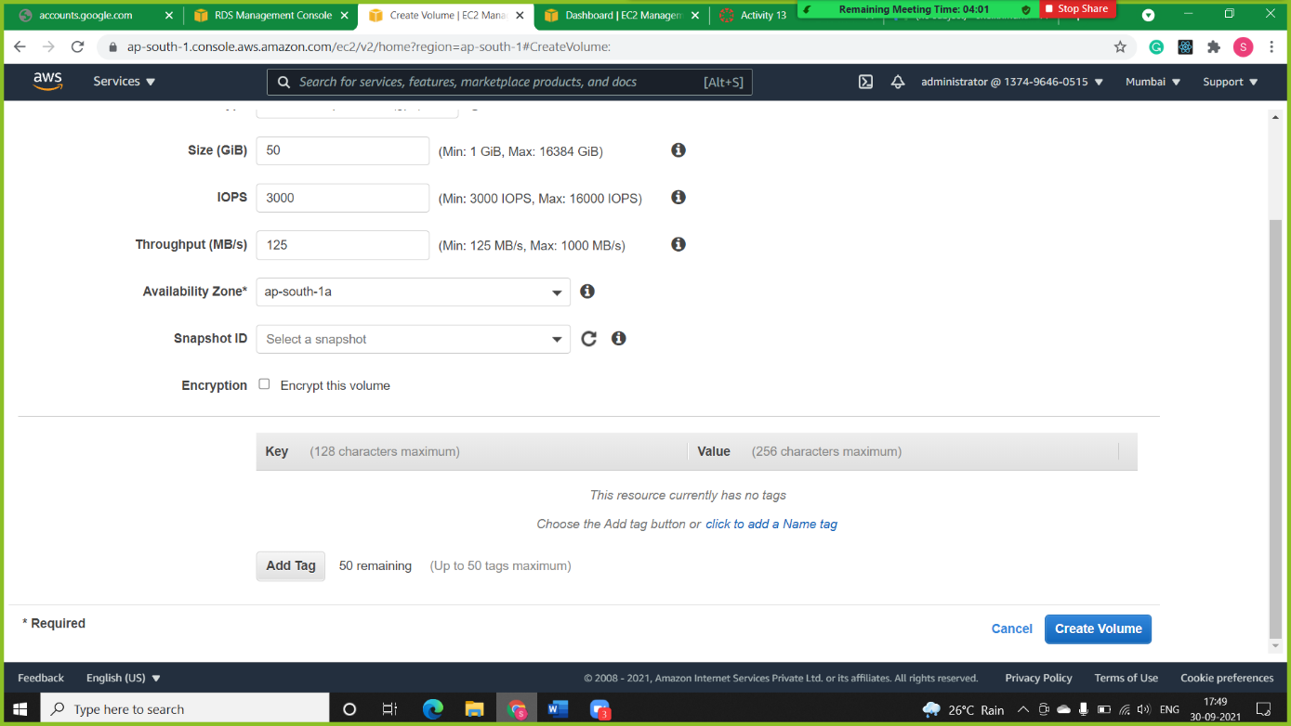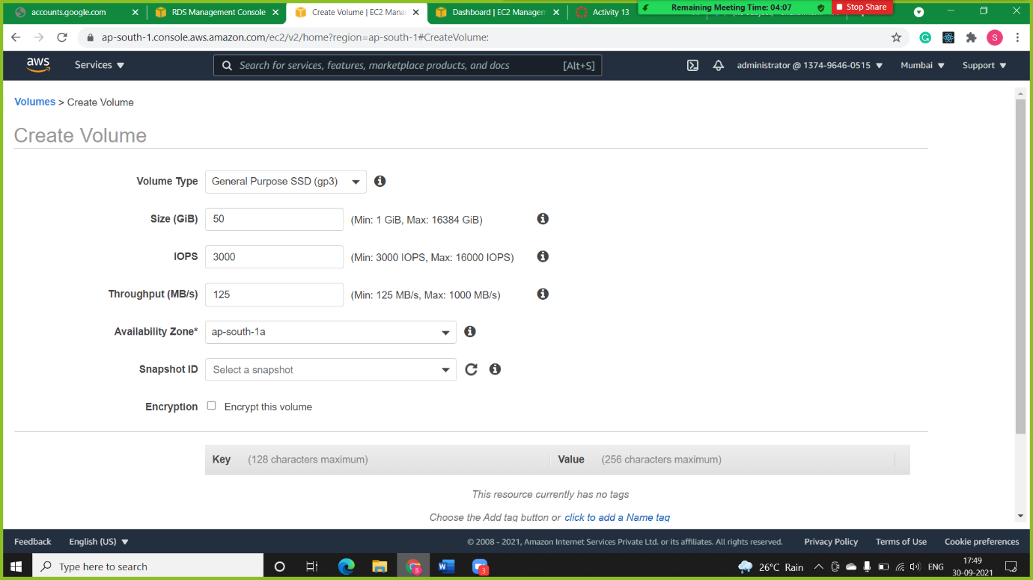

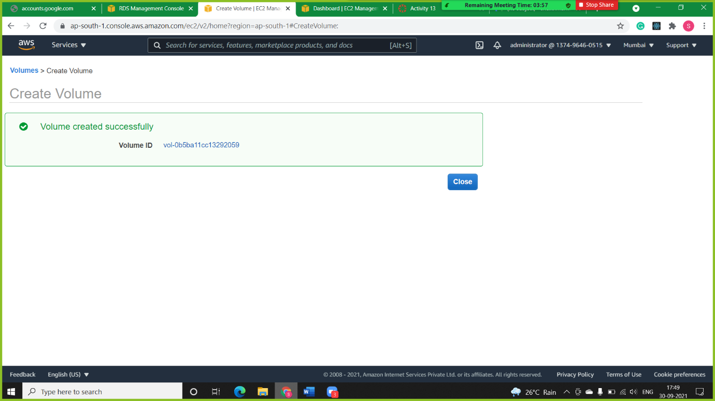

**Note:** We can see the volume created named ec2VolumeAttach with the size of 50 GB.

**Step 4**: In this step, we are attaching a volume to the instance we have created for it and selecting the same region as the instance in volume. After that volume was attached successfully.

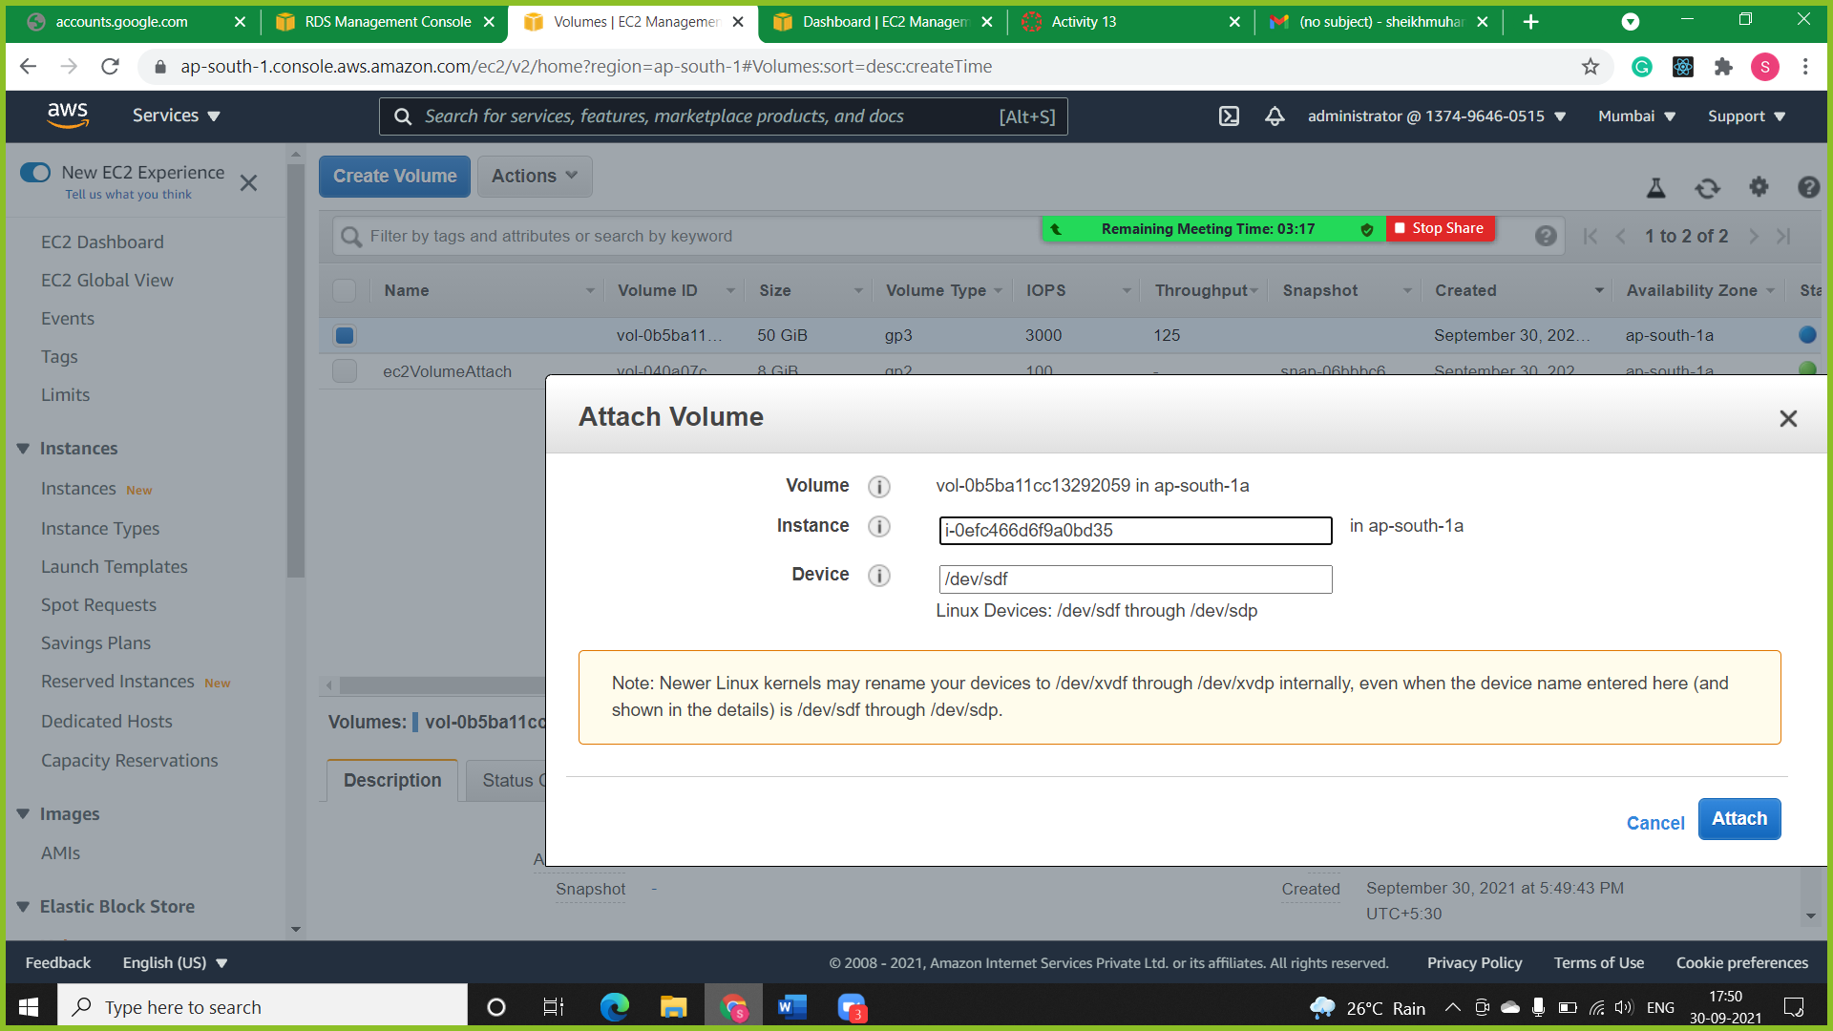

**Step 5:** we have successfully attached a volume but still, it is not available to use for any storage so we have opened an instance on putty and checked the partition through **df -h** and saw it is not available.

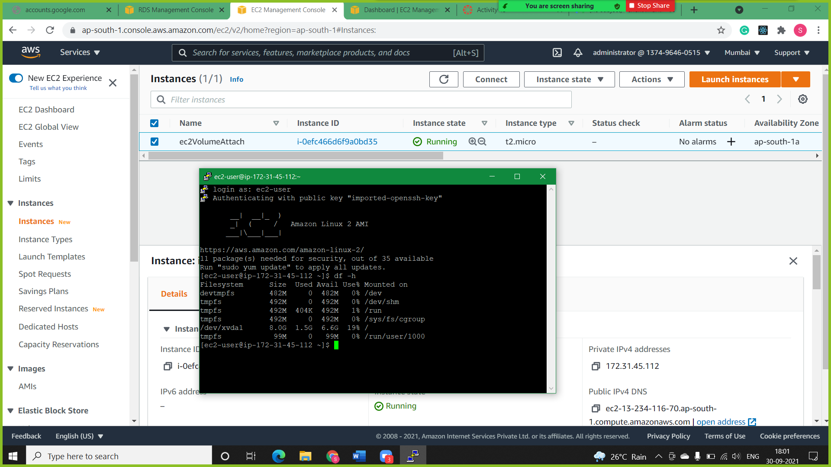

**Step 6:** We have to mount it for use so we will check for partition whether it has data or not. So, we will use **file -s/dev/xvdf** command to check it and we found that the disk is empty.

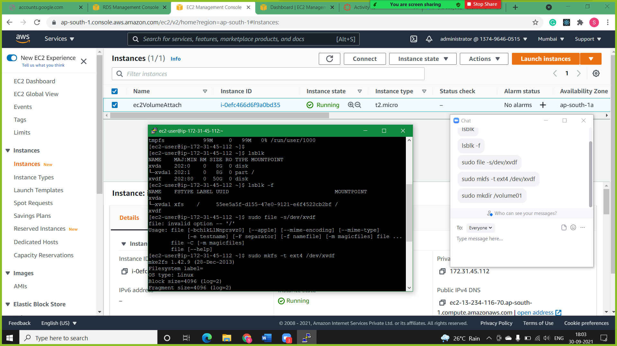

**Step 7:** Now, we are formatting the partition using **mkfs (**make file system) format and extension as **ext4** to the partition.

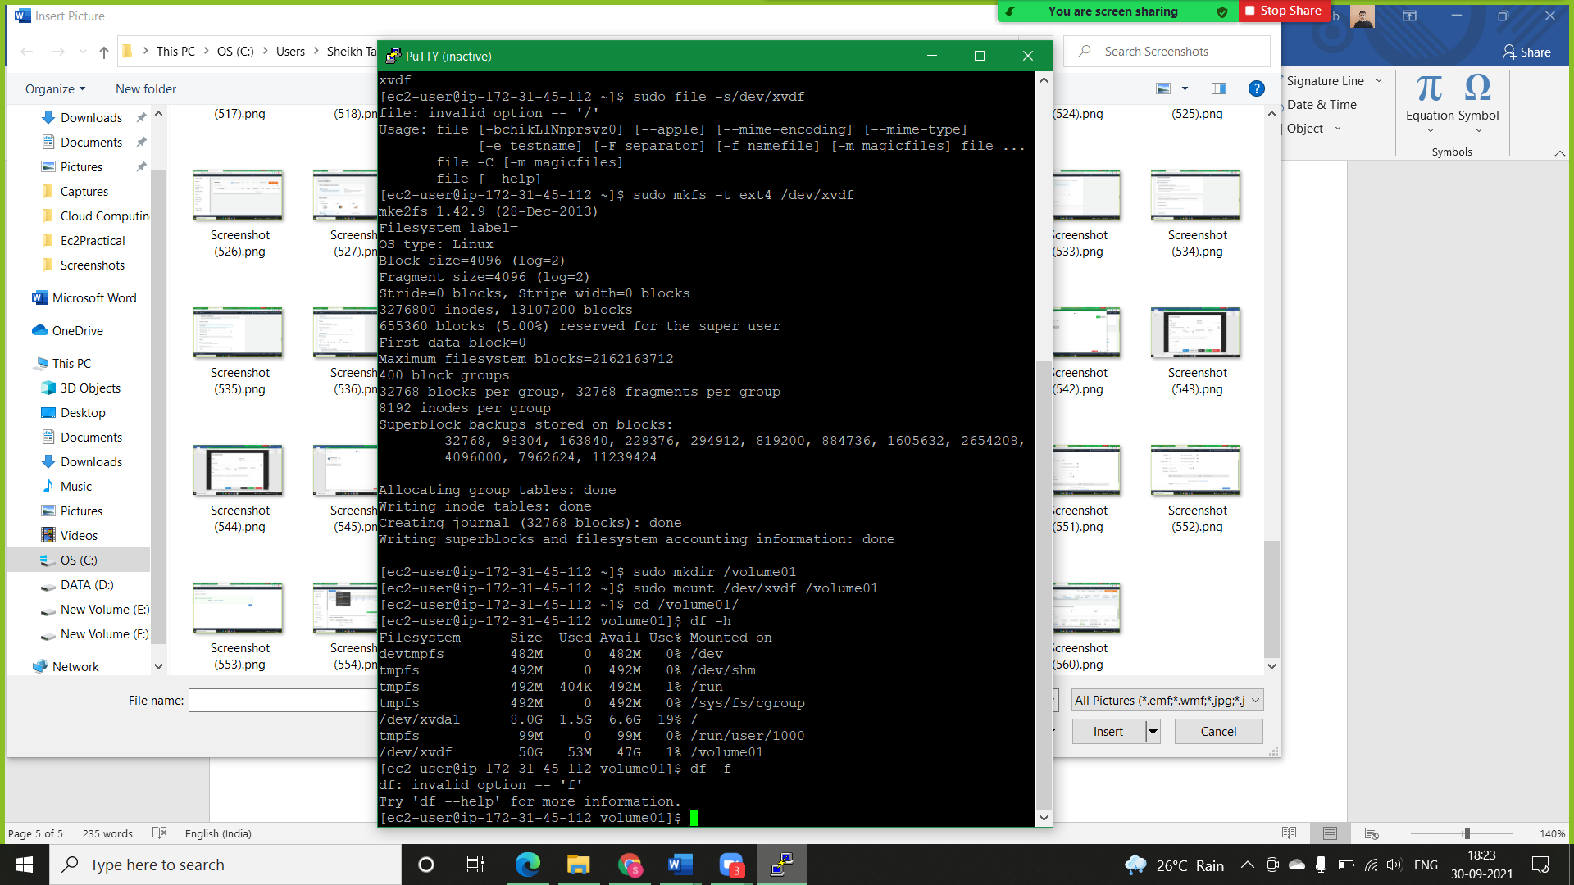

**Step 8:** Now, we have to create a directory t mount the partition because the partition can be mounted only on the directory, so we mounted it using **mount /dev/xvdf /directory name**command.



**Step 9:** So, we have mounted the partition successfully and it is ready for use and store data, we can check that using **df -f** command in the partition list and it is mounted on the directory we created.

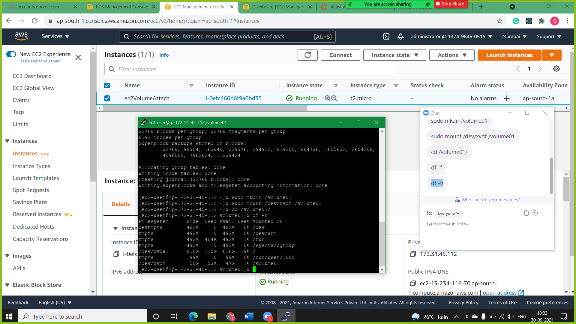

**Step 10:** In Below snapshot we can see our attached volume is available in storage.

